Step: 01 GKE : Google Kubernetes Engine. Kubernetes is the most popular container orchestrator tool.

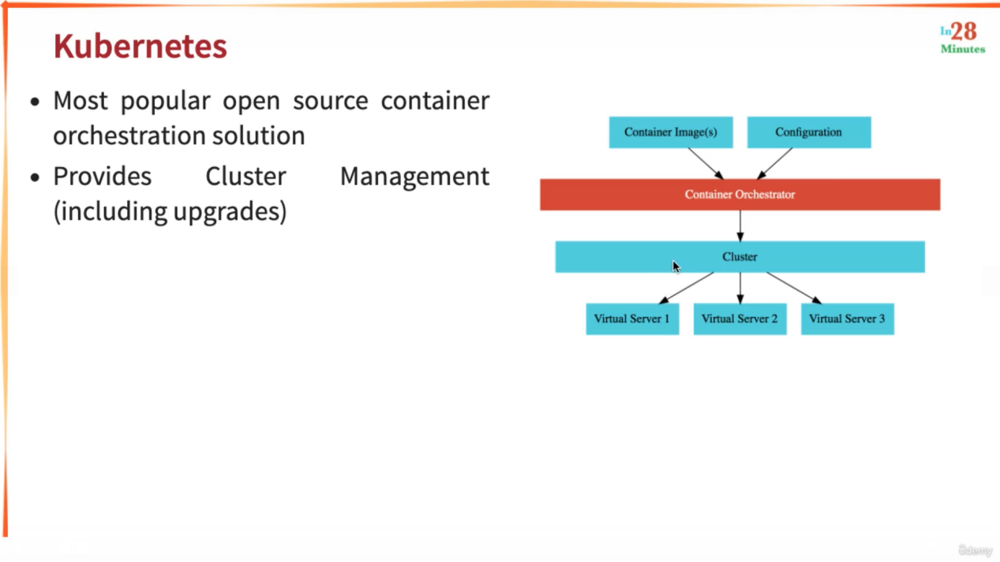

Kubernetes manages cluster management.Whatever workload (VS1, VS2) you want to deploy, you deploy it into server. Kubernetes helps to create the cluster and manage them and upgrade them. In a cluster you can have different virtual machines with different hardware configurations.

It has features like:

Auto repair : whenever a node fails it will be automatically replaced.

POD: number of instances for a particular micro-service. If number of pods need to be increased then cluster auto-scaling is required which will increase the number of nodes.

Step 02:

Recently a new GKE mode is introduced - Autopilot (simplifies cluster management). However, for the demo, we want to use Standard. Choose Standard in the next step!

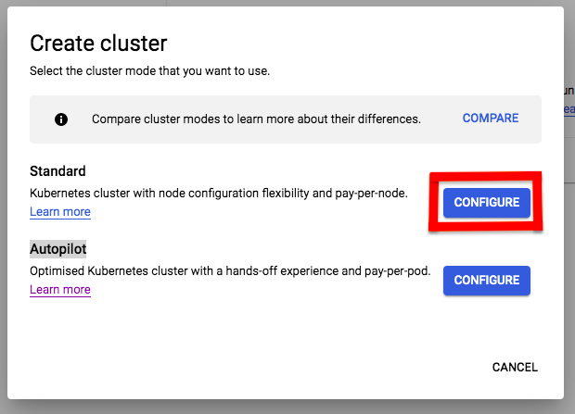

2: Here are some of the commands we will run in the next few steps (Refer back to this if you have any problems!)

1. gcloud config set project my-kubernetes-project-304910
2. gcloud container clusters get-credentials my-cluster --zone us-central1-c --project my-kubernetes-project-304910
3. kubectl create deployment hello-world-rest-api --image=in28min/hello-world-rest-api:0.0.1.RELEASE
4. kubectl get deployment
5. kubectl expose deployment hello-world-rest-api --type=LoadBalancer --port=8080
6. kubectl get services
7. kubectl get services --watch
8. curl 35.184.204.214:8080/hello-world
9. kubectl scale deployment hello-world-rest-api --replicas=3
10. gcloud container clusters resize my-cluster --node-pool default-pool --num-nodes=2 --zone=us-central1-c
11. kubectl autoscale deployment hello-world-rest-api --max=4 --cpu-percent=70
12. kubectl get hpa
13. kubectl create configmap hello-world-config --from-literal=RDS_DB_NAME=todos
14. kubectl get configmap
15. kubectl describe configmap hello-world-config
16. kubectl create secret generic hello-world-secrets-1 --from-literal=RDS_PASSWORD=dummytodos
17. kubectl get secret
18. kubectl describe secret hello-world-secrets-1
19. kubectl apply -f deployment.yaml
20. gcloud container node-pools list --zone=us-central1-c --cluster=my-cluster
21. kubectl get pods -o wide
23. kubectl set image deployment hello-world-rest-api hello-world-rest-api=in28min/hello-world-rest-api:0.0.2.RELEASE
24. kubectl get services
25. kubectl get replicasets
26. kubectl get pods
27. kubectl delete pod hello-world-rest-api-58dc9d7fcc-8pv7r
29. kubectl scale deployment hello-world-rest-api --replicas=1
30. kubectl get replicasets
31. gcloud projects list
33. kubectl delete service hello-world-rest-api
34. kubectl delete deployment hello-world-rest-api
35. gcloud container clusters delete my-cluster --zone us-central1-c

Hands on

Creating a new project

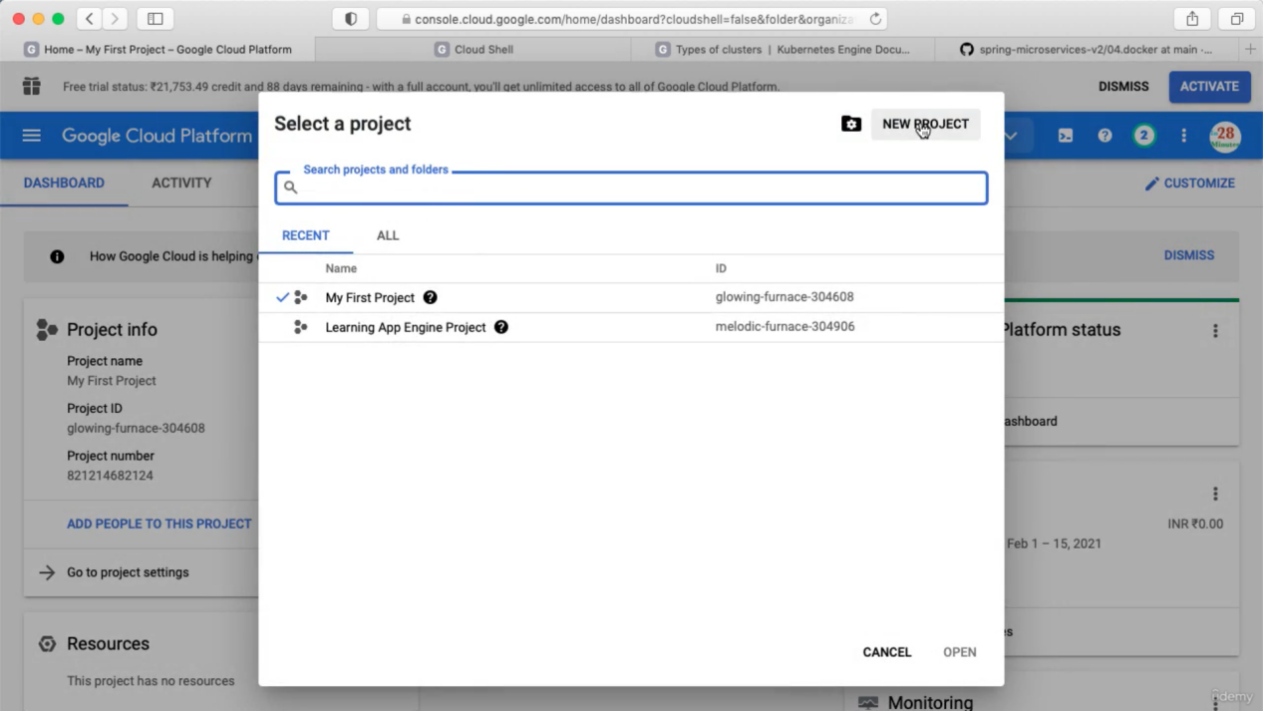

Click Project TAB beside Activity TAB. Then click NEW PROJECT and then give a name.

Select this newly created project and inside this we will create a Kubernetes Cluster

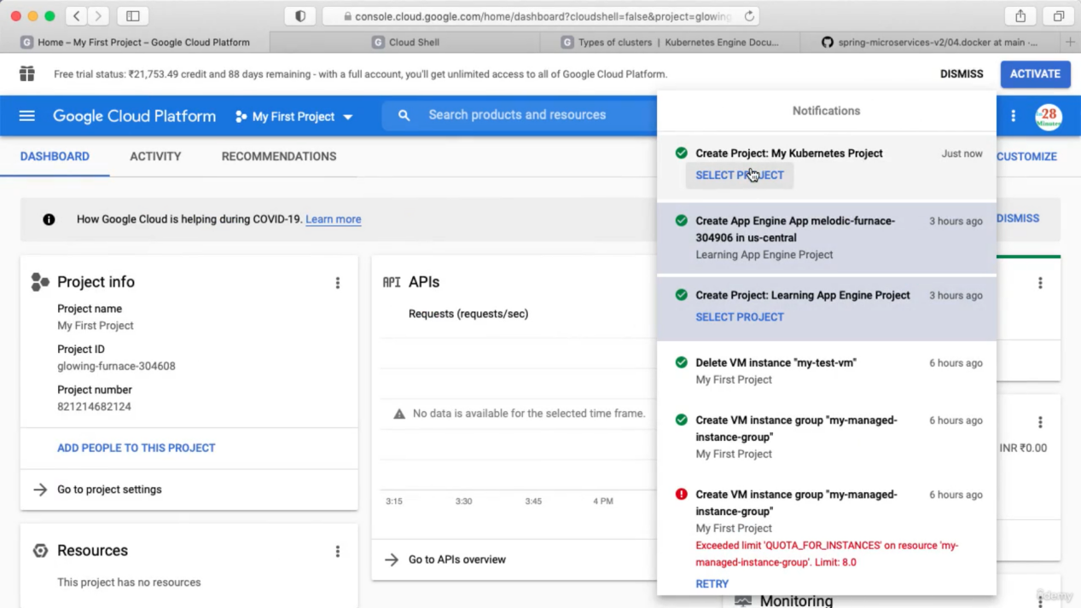

Search for Kubernetes Engine

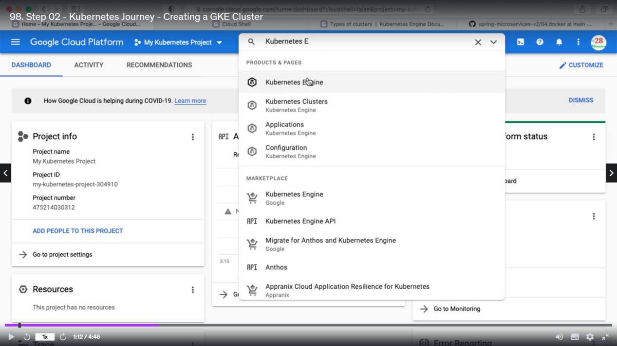

Before we use Kubernetes Engine we need to enable Kubernetes API. This will automatically goes to Kubernetes API. We need to enable them.

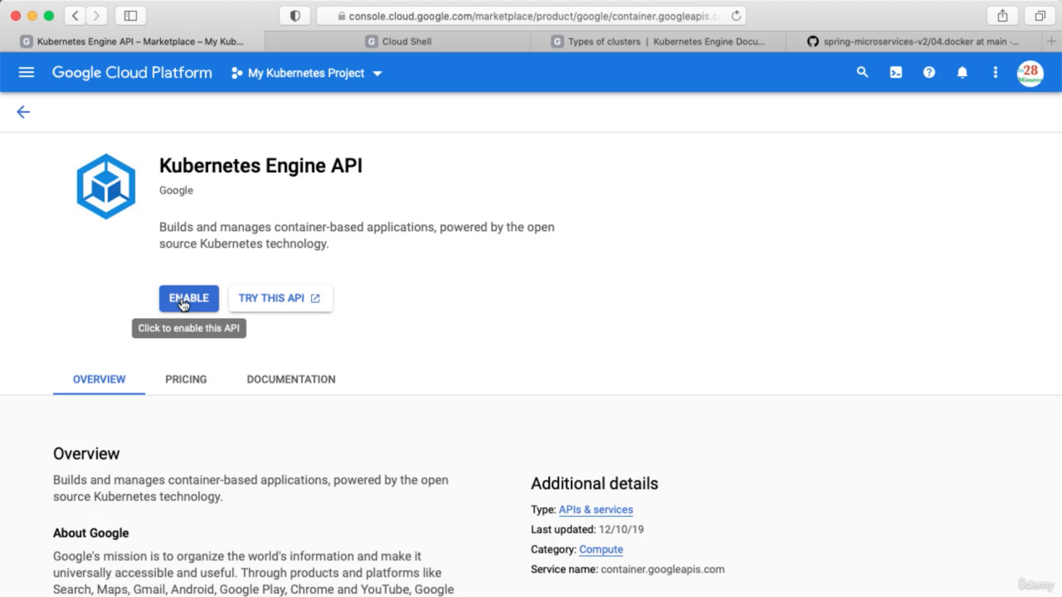

For Any service as they use API, so we need to enable the API before using the service.

Now go to Kubernetes Engine and click on create cluster.

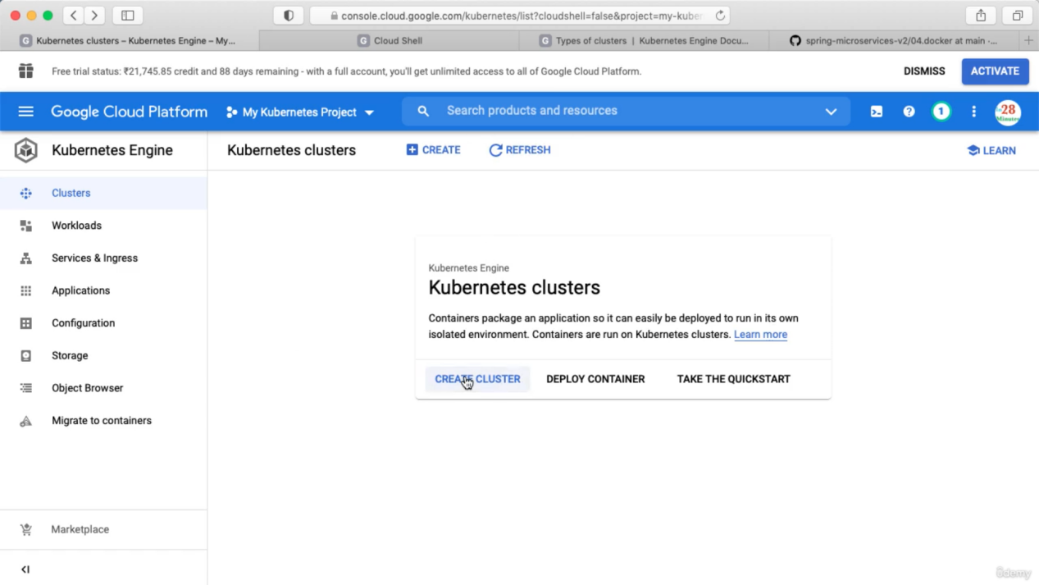

Next click Standard (We have to configure the details). About Autopilot => it is mostly managed by GKE. PPT has details about Autopilot.

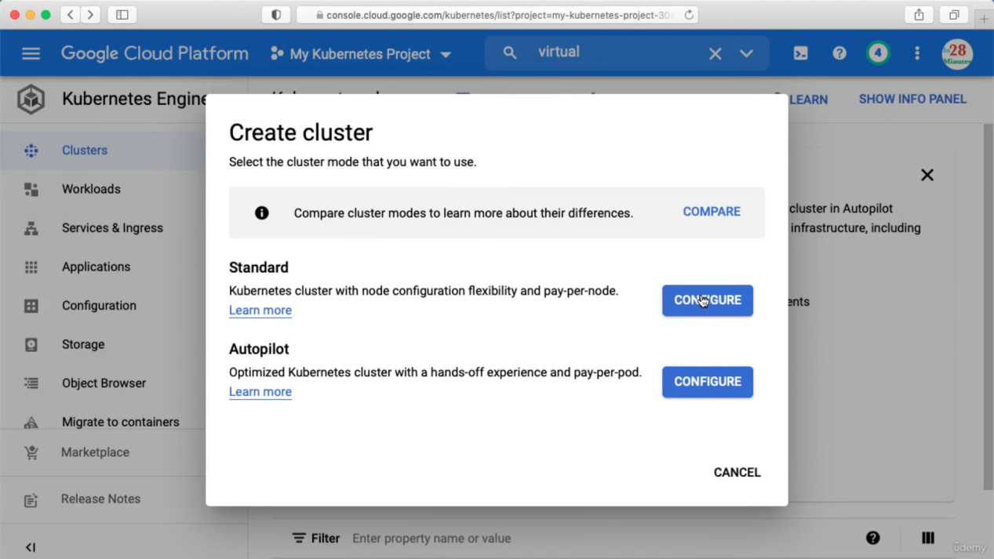

Now give a name and click create

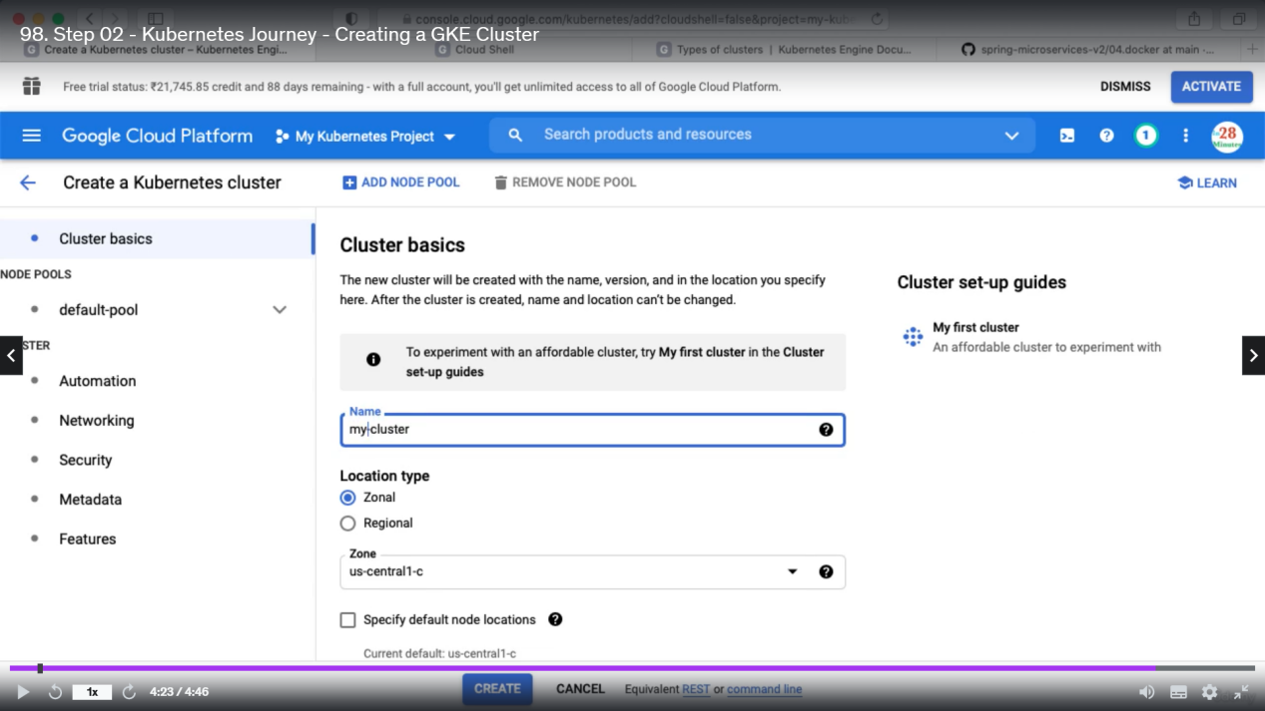

We can also do this by using below command

gcloud container clusters create. (for kubernetes all command starts with gcloud container)

Commands executed in next step:

Here's the command to create a deployment which we will run in the next step!

Use this to avoid making typos!

kubectl create deployment hello-world-rest-api (this is deployment name)

--image=in28min/hello-world-rest-api:0.0.1.RELEASE

Step 3: Create a deployment

Our newly created cluster will look like below

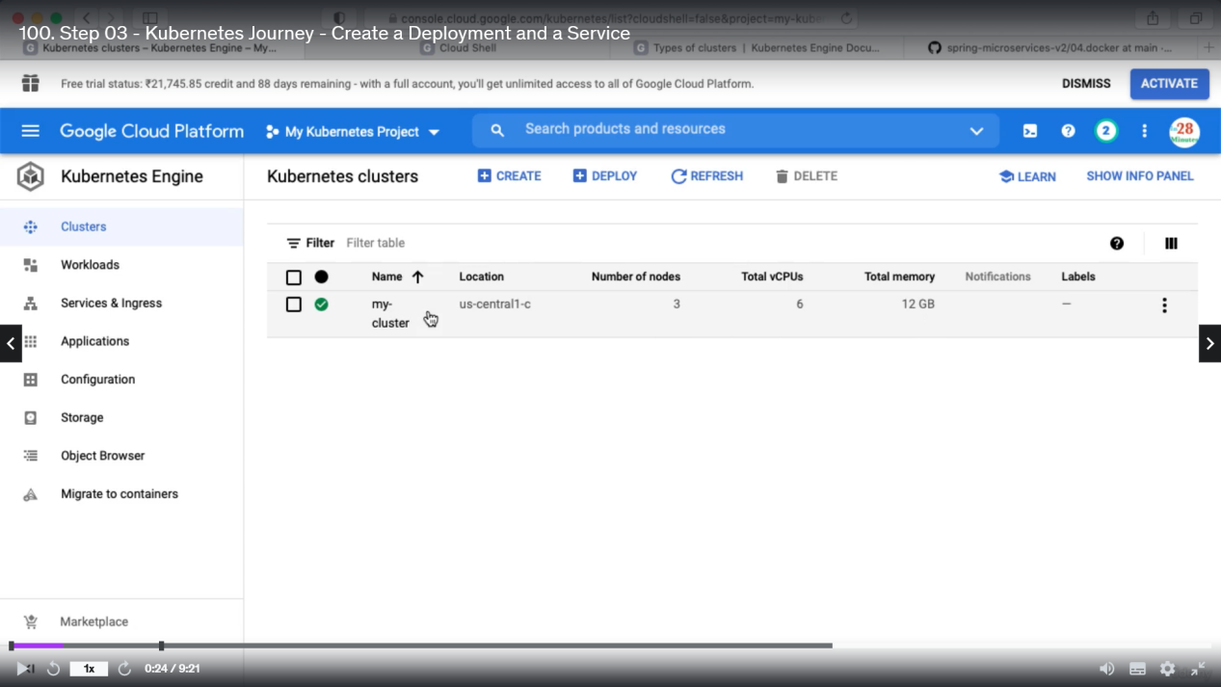

To be able to access the project from cloud shell we need to first copy the project ID

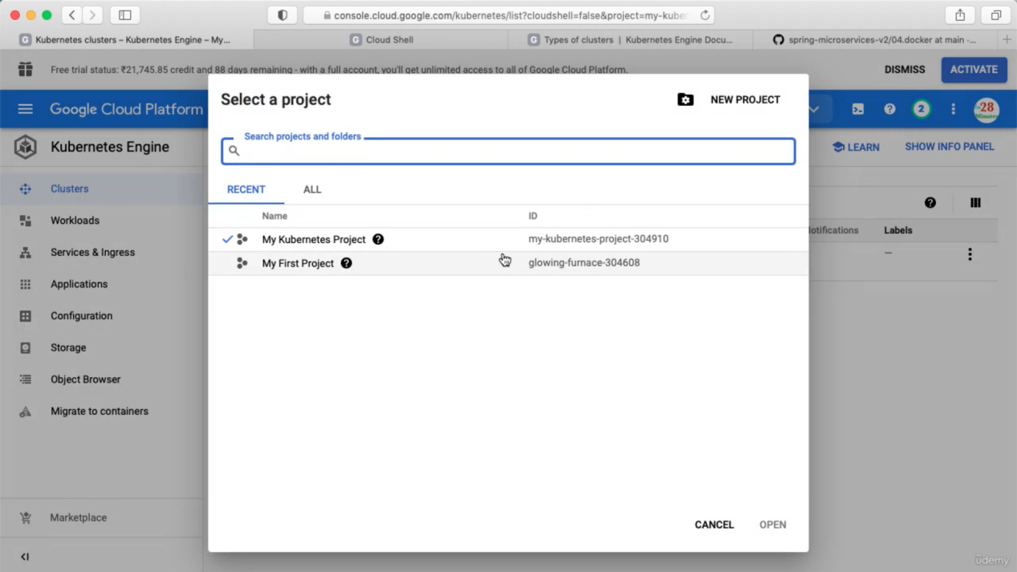

Then we need to execute like below

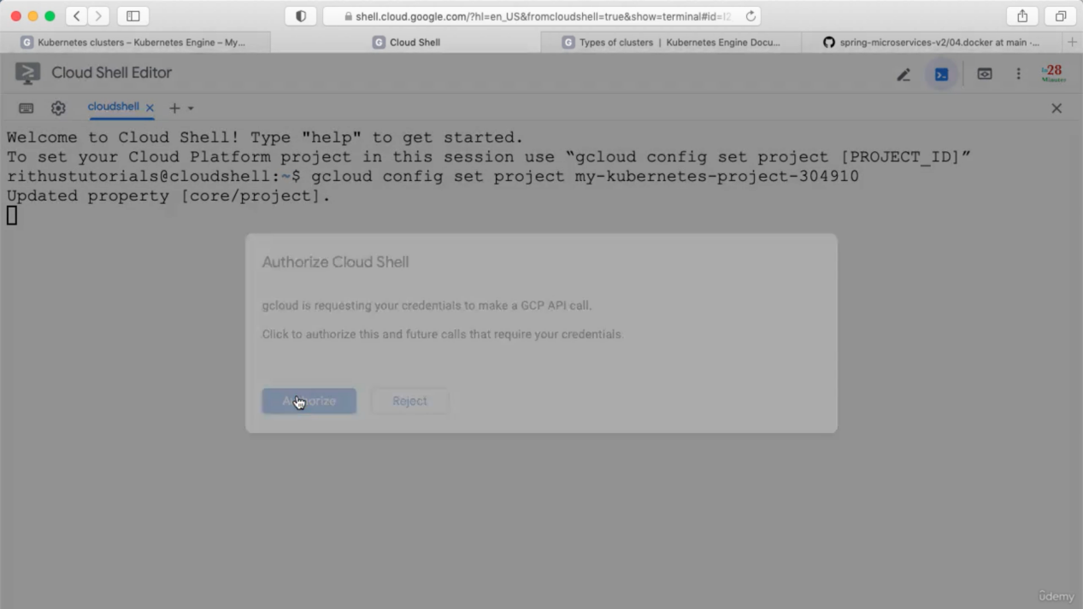

Next we need to connect to the kubernetes cluster

You can get the command for connecting with kubernetes cluster by clicking below

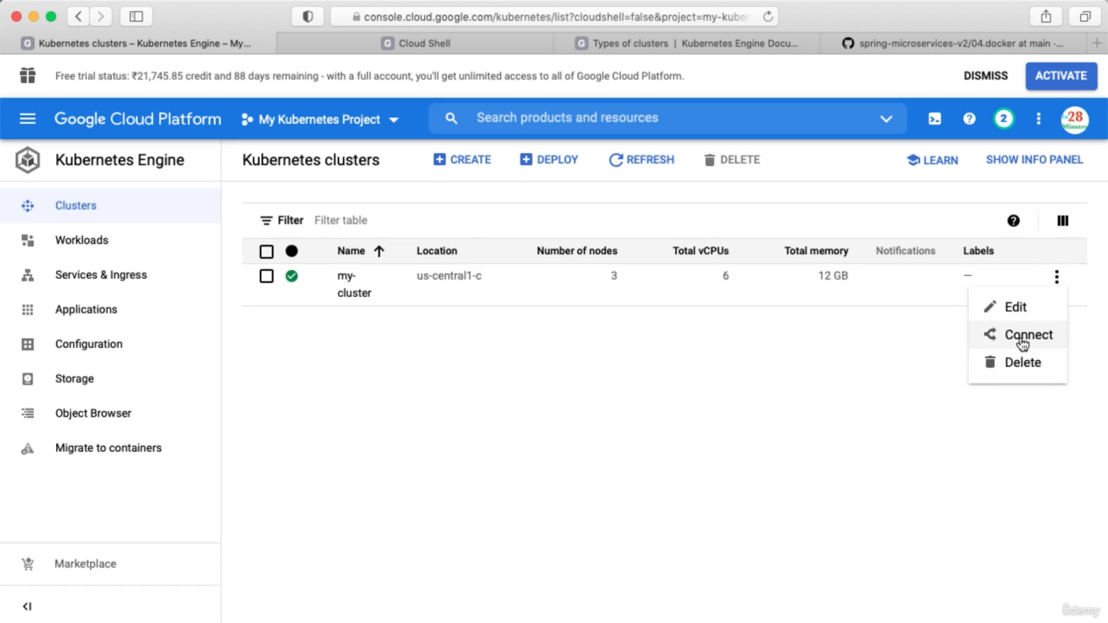

As per the exam, we need to remember the commands

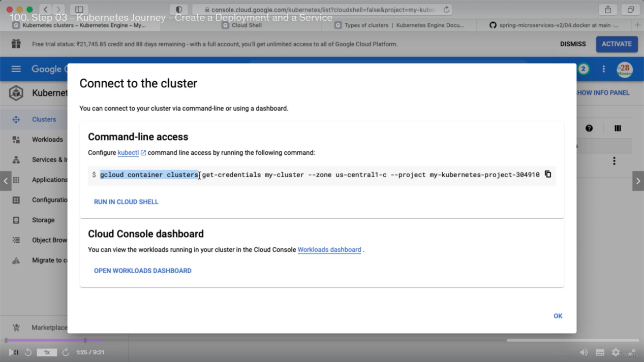

(for creating cluster we need to use create instead of get-credentials)

Now we need to deploy microservice to Kubernetes

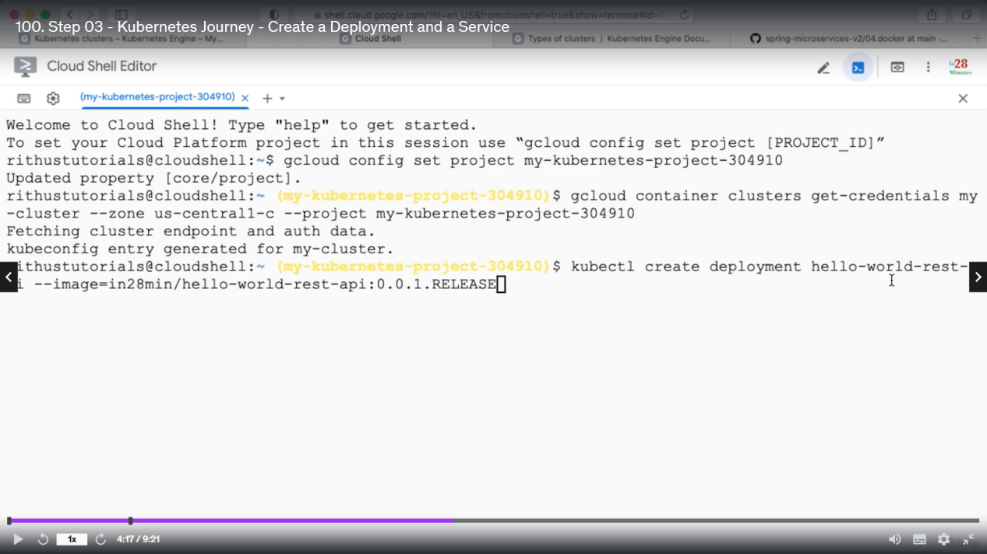

We need to specify deployment name and image here. (this kubernetes commands will starts with kubectl)

Kubectl get deployment => will show you deployment details

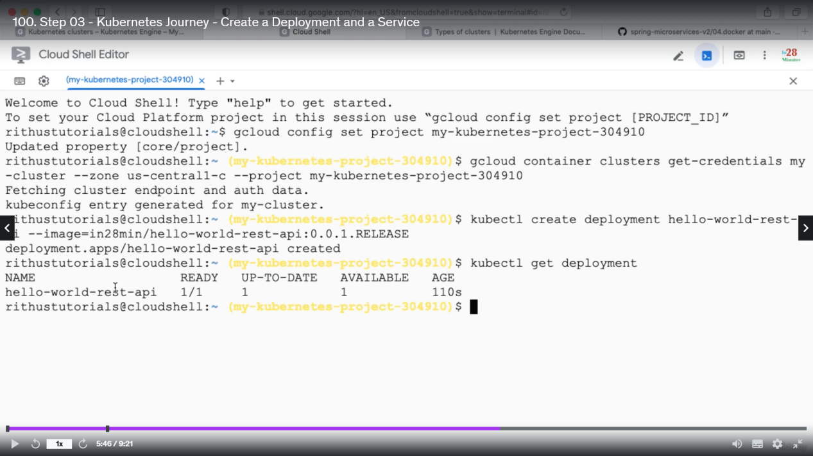

In order to use the service from outside we need to expose this deployment by using below command. --type=LoadBalancer means whenever we create a service, in the background GKE will create a Load Balanecr for us.

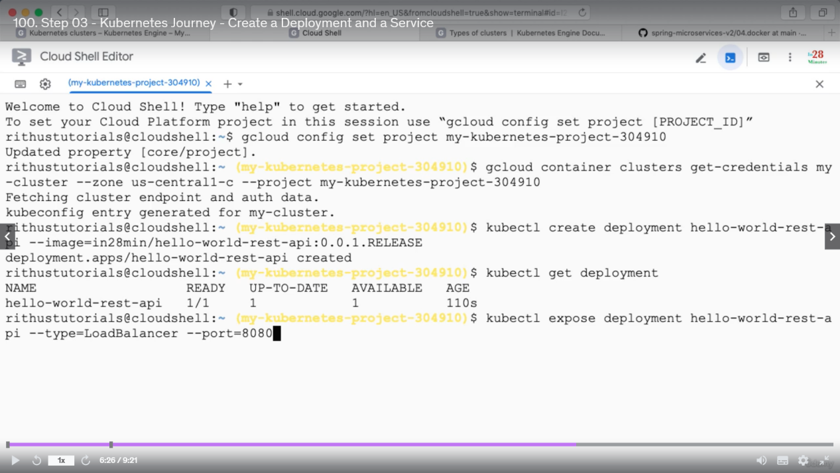

So, now internally kubernetes services will be created, we can also see the status of this services.

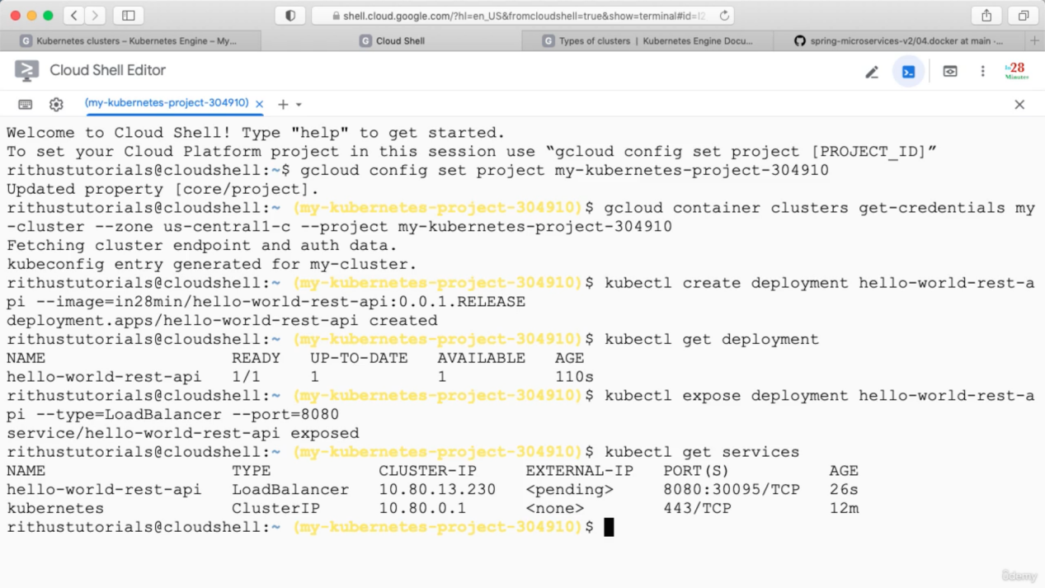

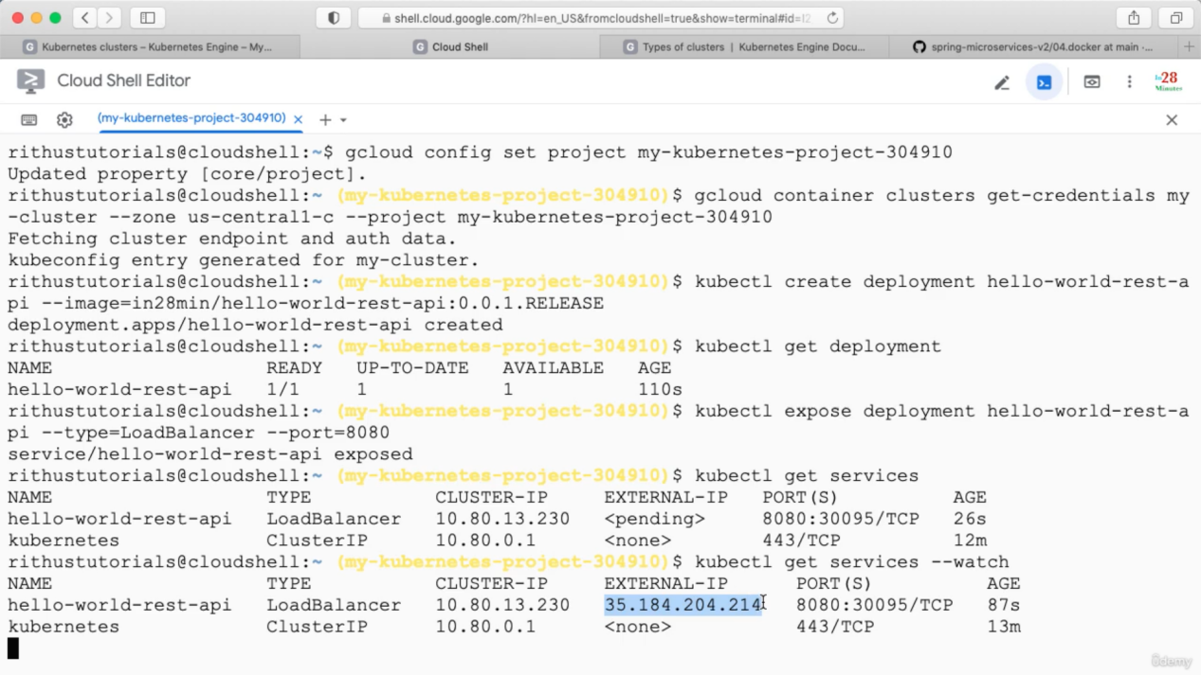

Test API

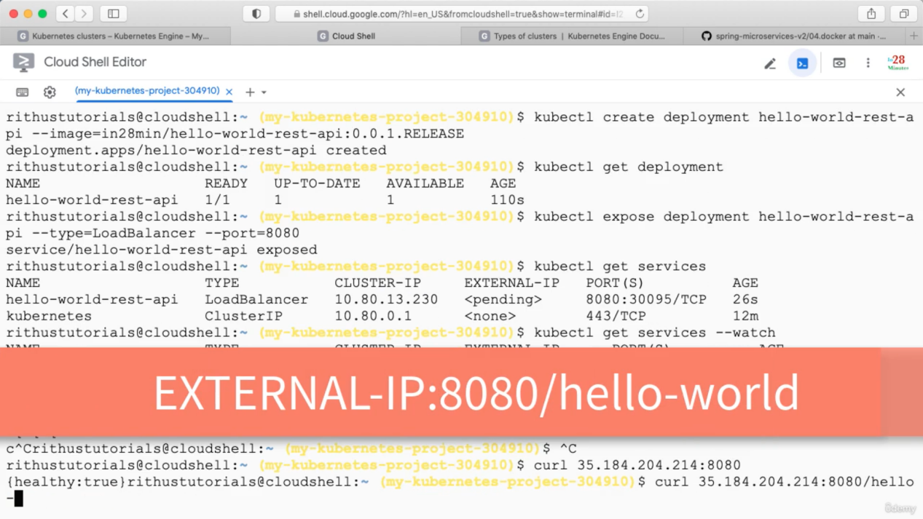

Ctrl+ c to close the watch.

Step 4:

If we need specific nodes with specific setup we can create this inside kubernetes cluster

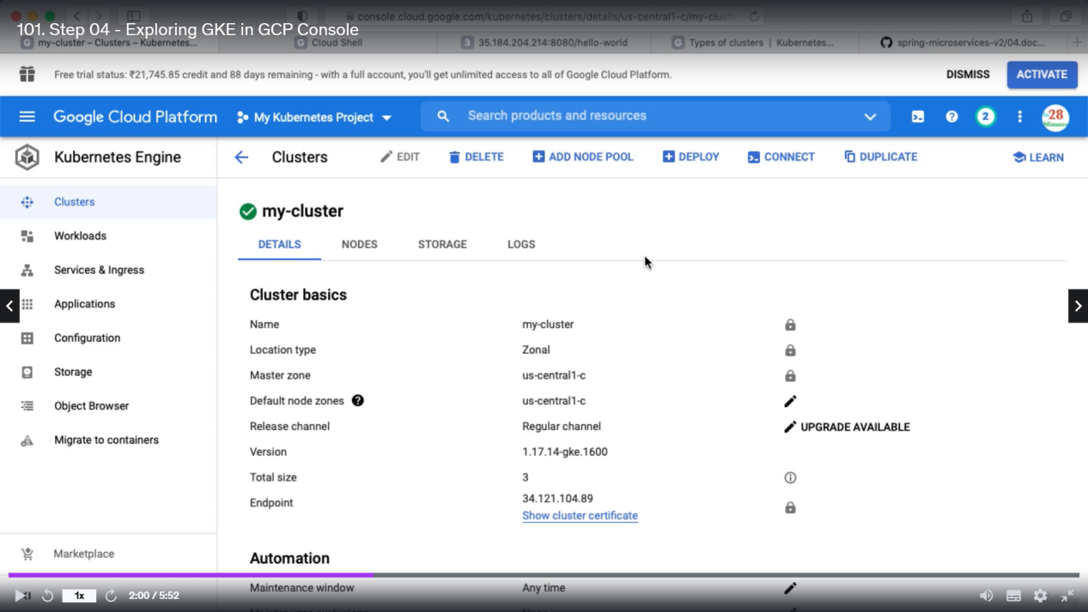

By default kubernetes Node pool is created with 3 nodes.

Inside workload we can see what is running inside the kubernetes cluster

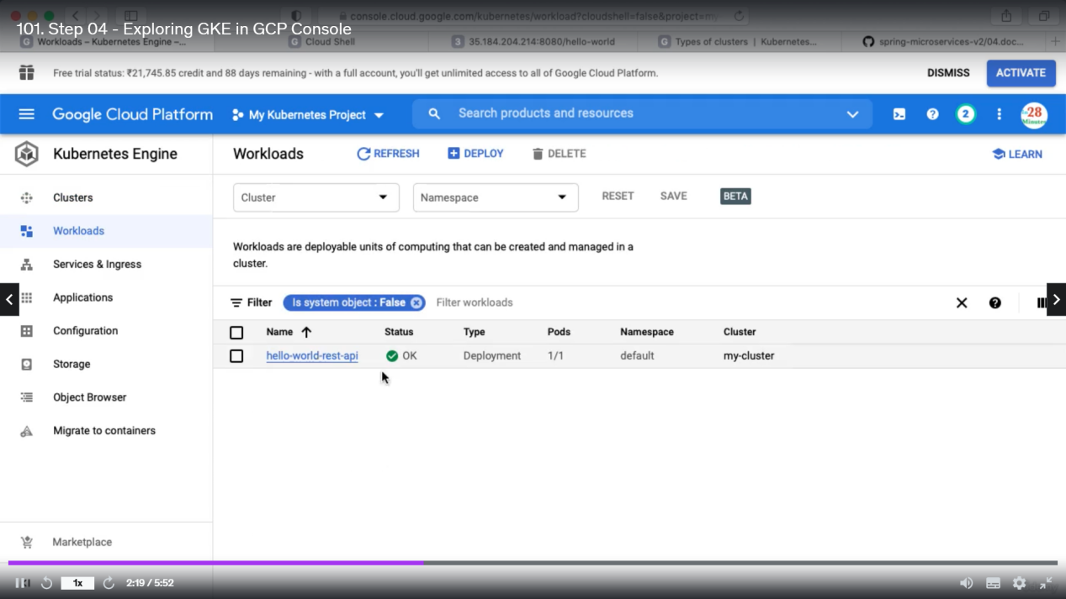

Kubectl get events => will let you know what is happening inside your cluster.

Step 5:

Increase the number of instances

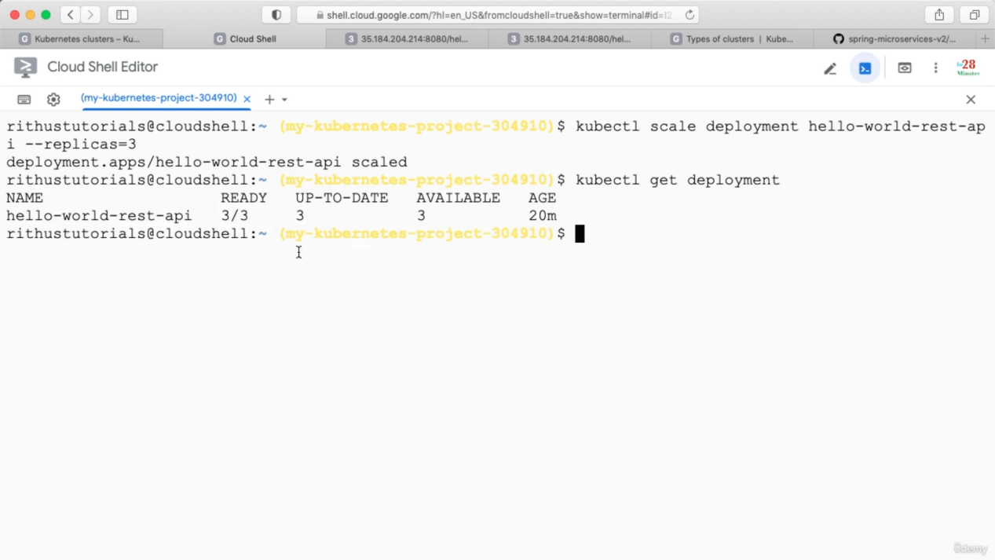

Watch will try to hit the endpoint continuously

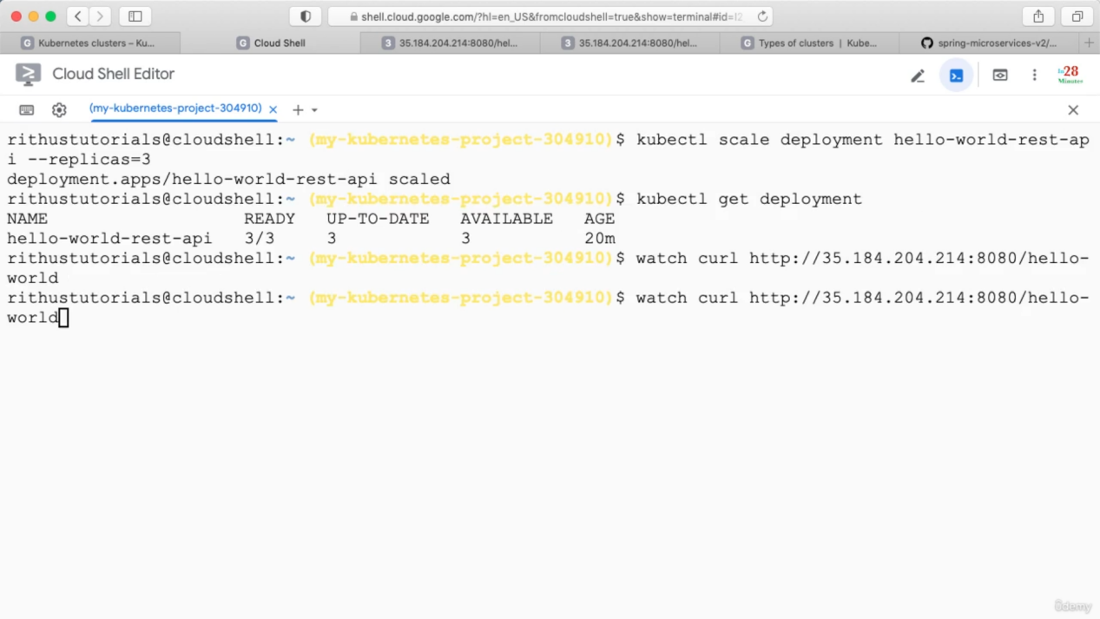

Get the pods

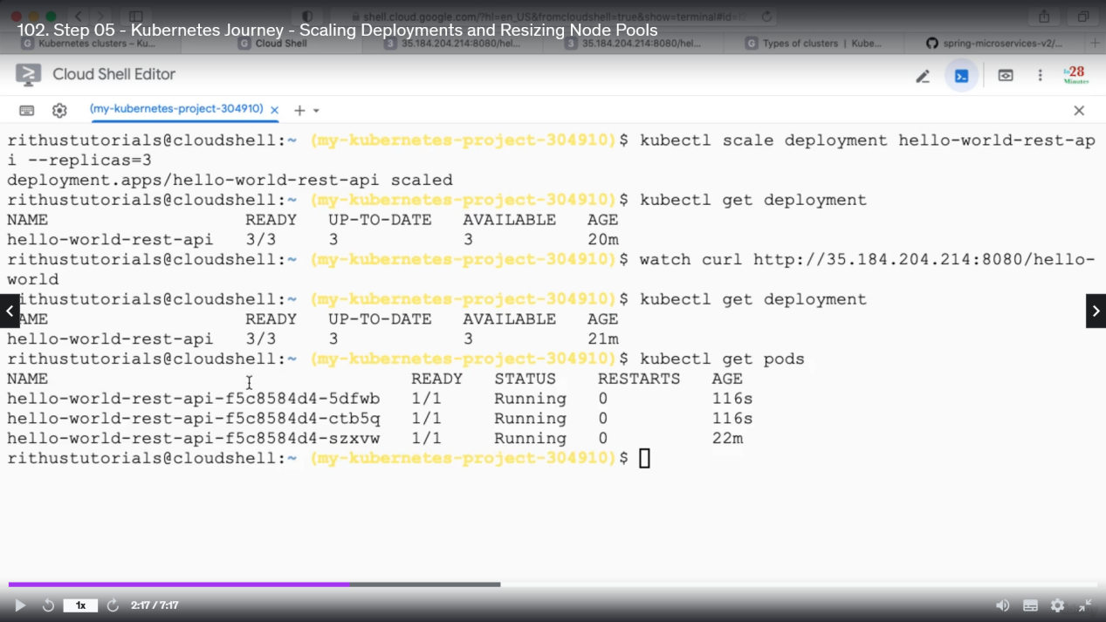

Now if we want to keep 100 instances so, to support this we need to increase the number of nodes

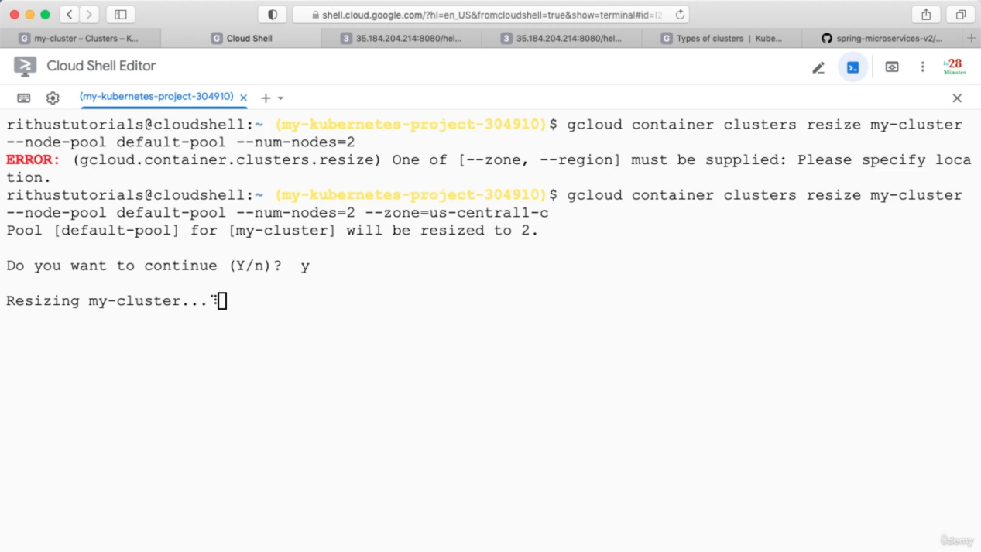

Step 06:

We can configure autoscale so that we don’t need to manually increase the number of instances/Pods

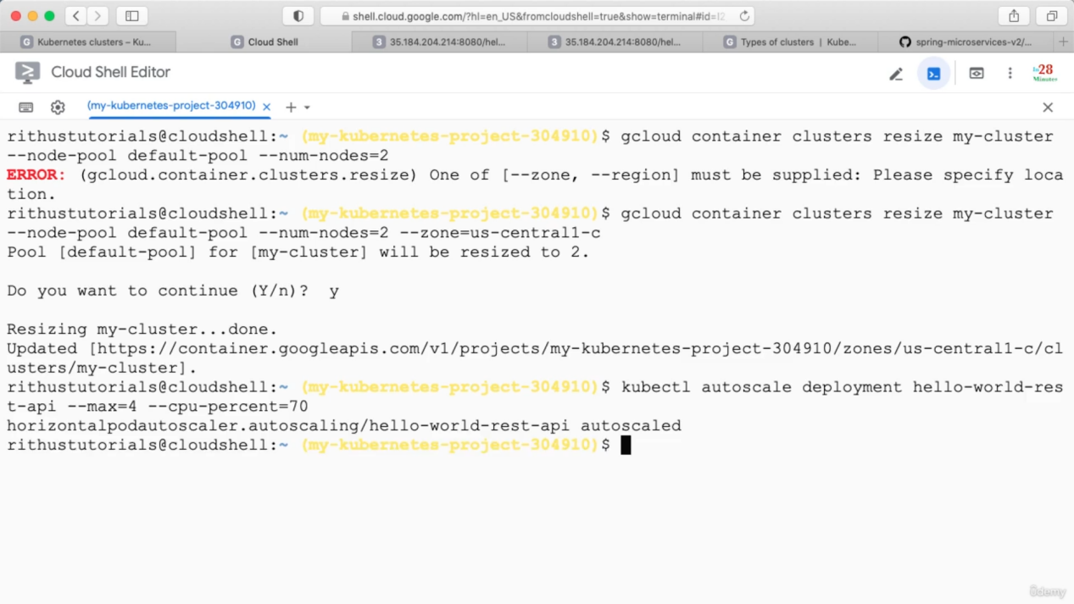

If you run below command you can see auto scaling details

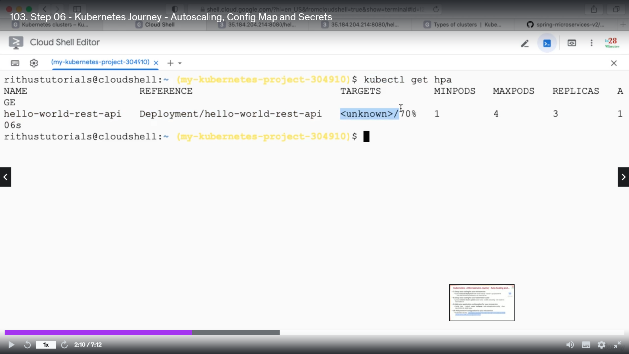

Hpa => horizontal pod autoscalar

For auto scaling Nodes use below command

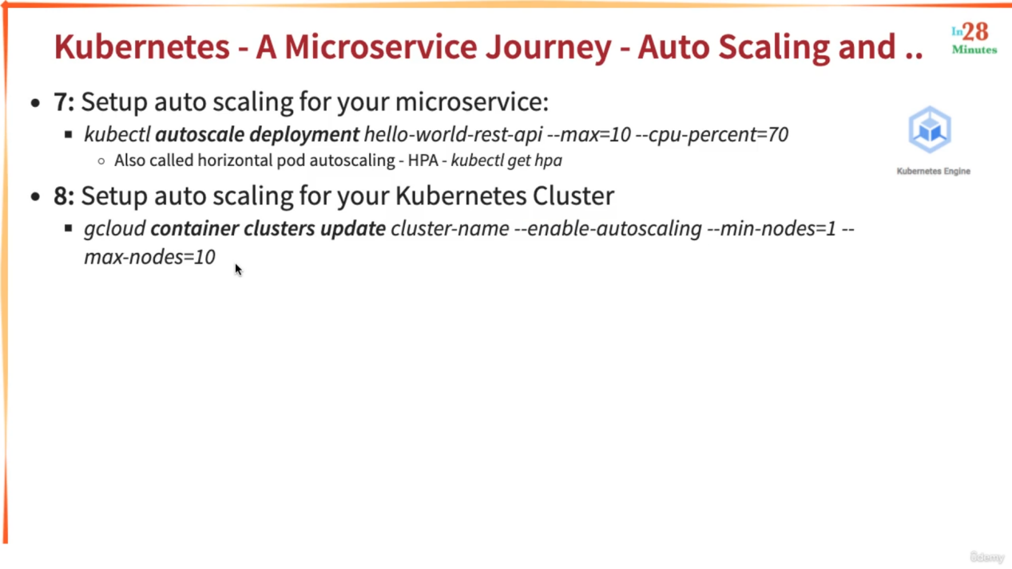

You can store configurtion related information inside config-map as below

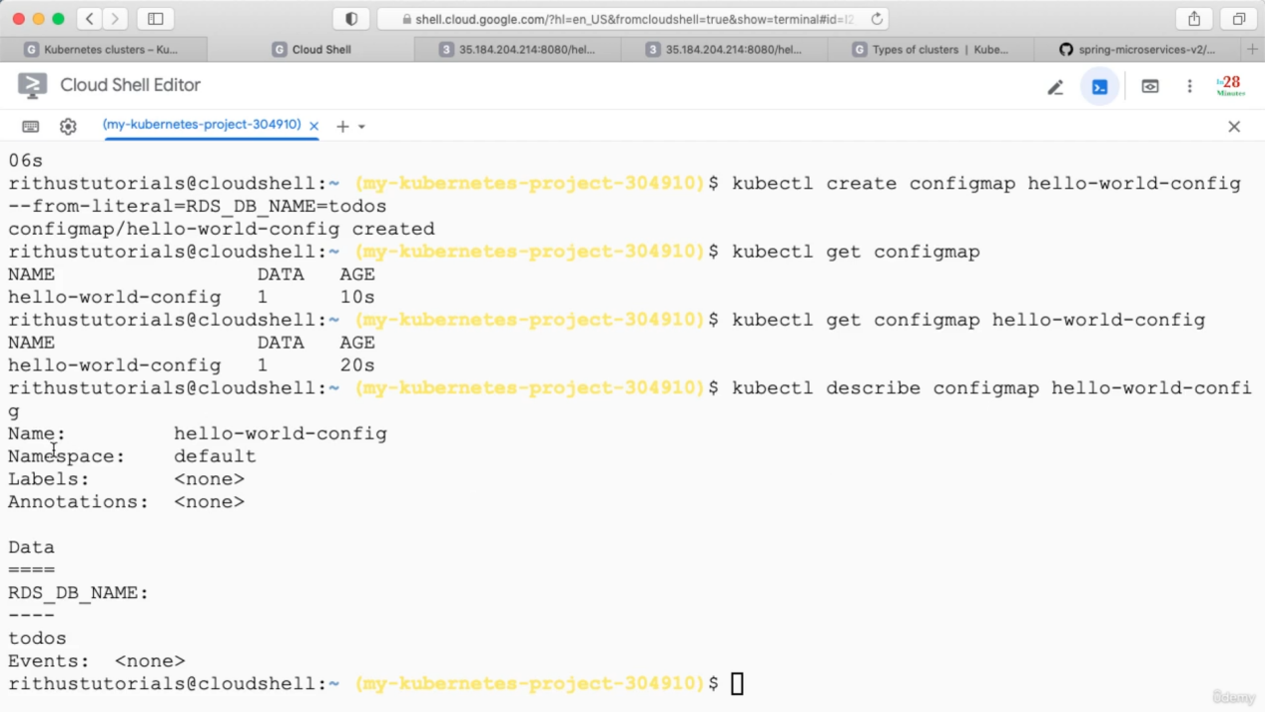

You can store secrets as below

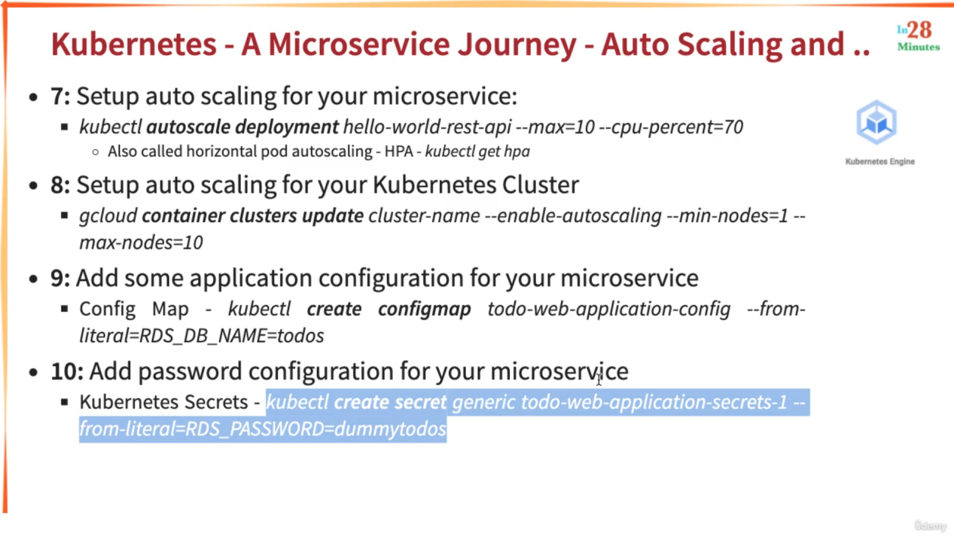

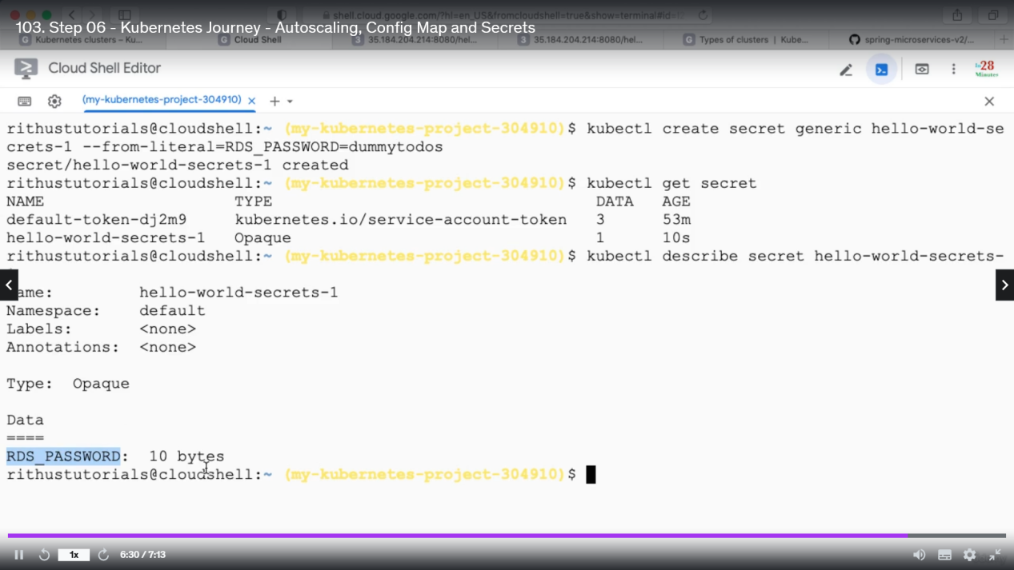

In config-map and secret you can store any number of values.

Step 07: Deployment via yaml.

We can also edit this yaml file. Click EDIT -> change value -> save

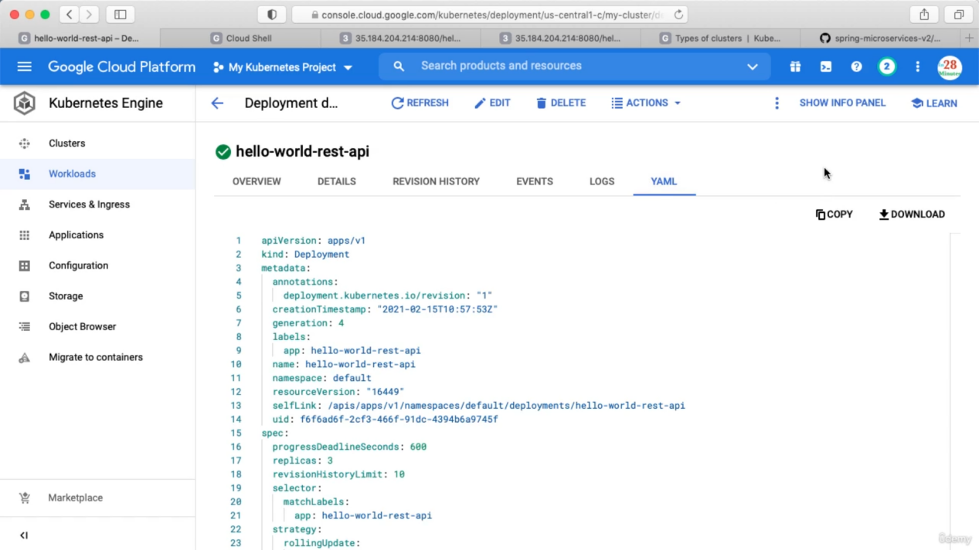

You can also deploy using yaml file using below command

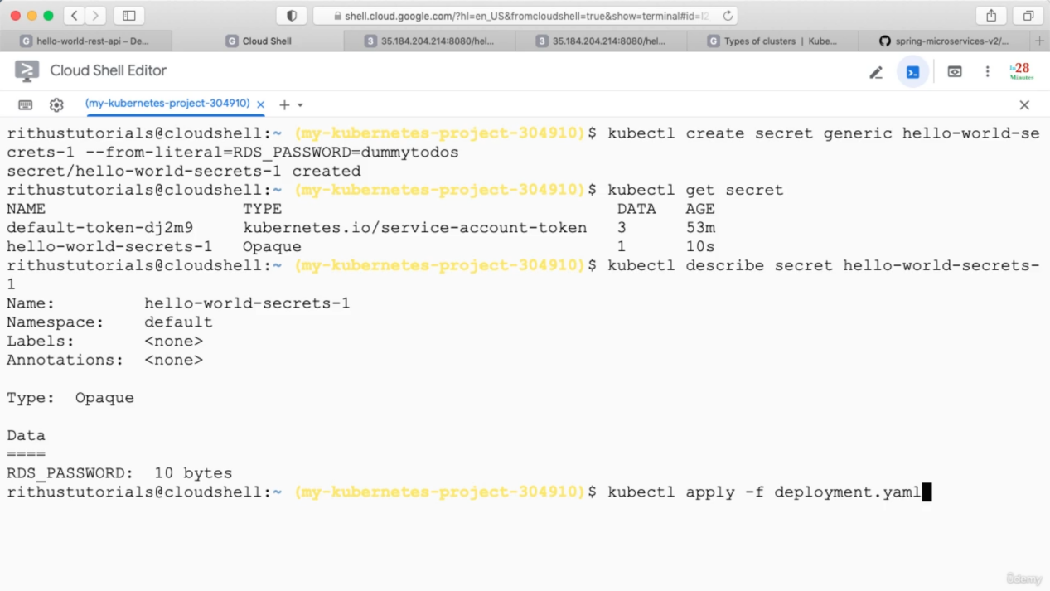

Step 8: PPT is enough.

A kubernetes cluster have master node and worker node. Whenever we run any kubeclt command it hits to master node. In the worker nodes our microservices run.

Inside Masternode Api Server handles the kubeclt commands flow, Scheduler decides if a new deployment has to trigger in which worker node it will place, Control Manager manages the worker nodes like if some node is unhealthy that has to be replaced. Etcd distributed database is used to store the state of your cluster.

Worker node component : kubelet -> manages the communication with master node.

Step 10: A pod can have one or more container. Below commands used to get details of PODs.

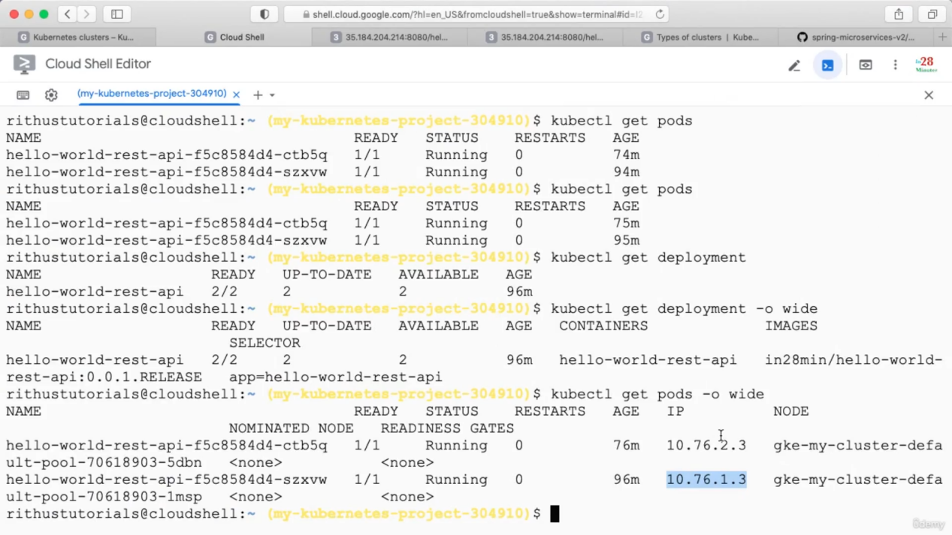

POD Status: Pending means it will be deployed to one of the nodes.

Unknown means master is not able to figure out what is the status of a POD.

Step 11: Deployment vs Replica set

Below command is used to update the deployment

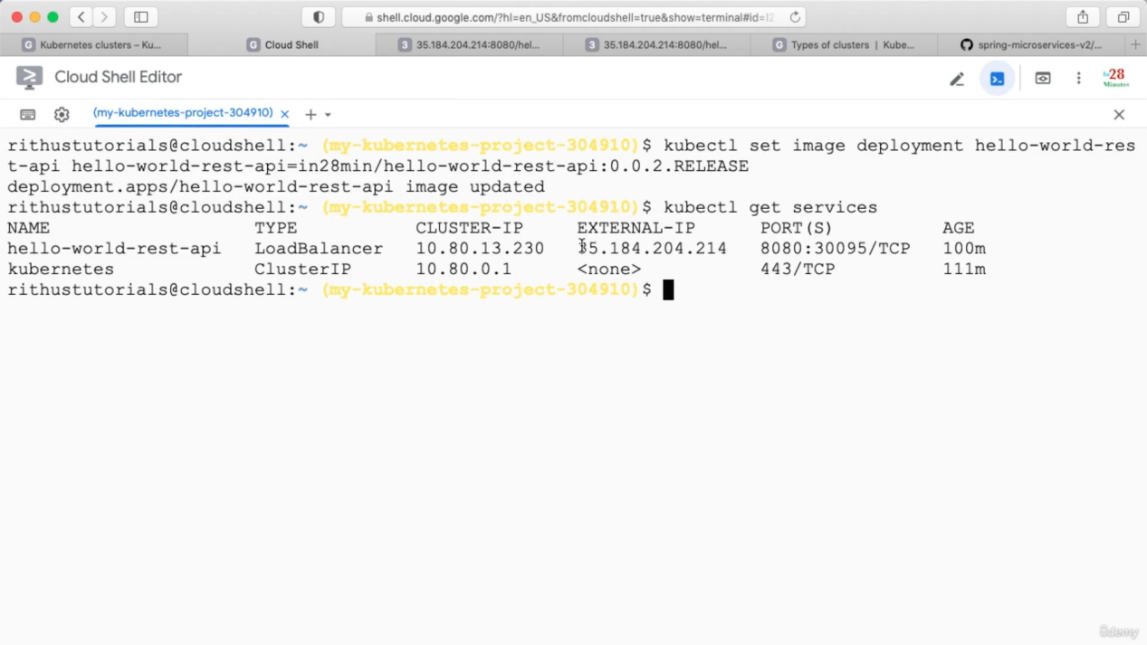

Replica set belongs to specific version

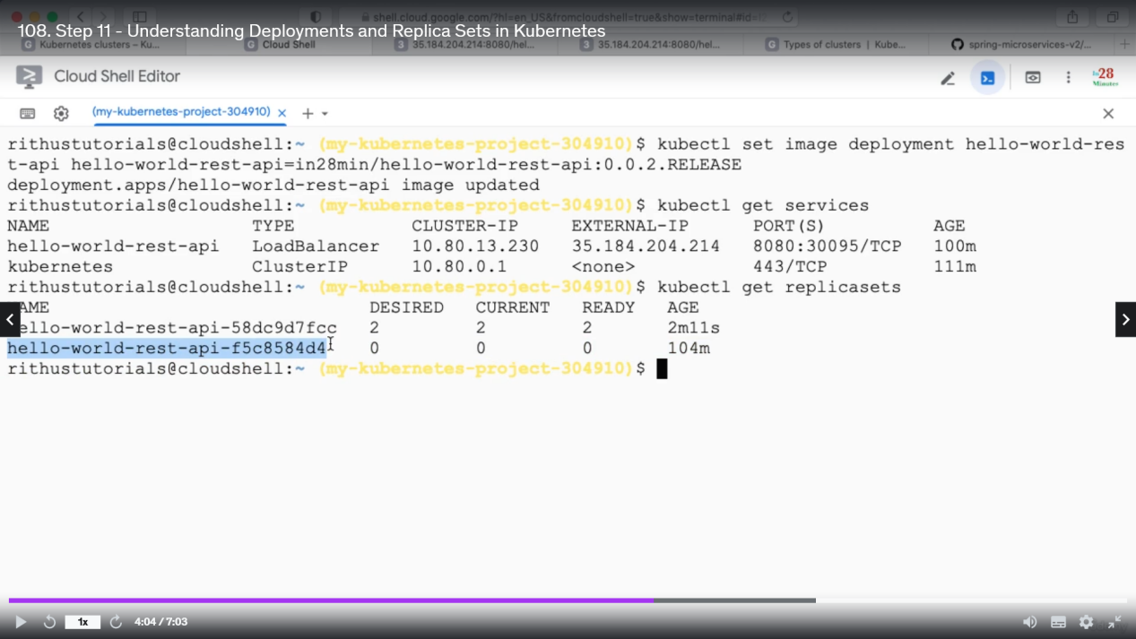

If we delete a POD, replica set will realize 2 instances must be running so it will create another POD.

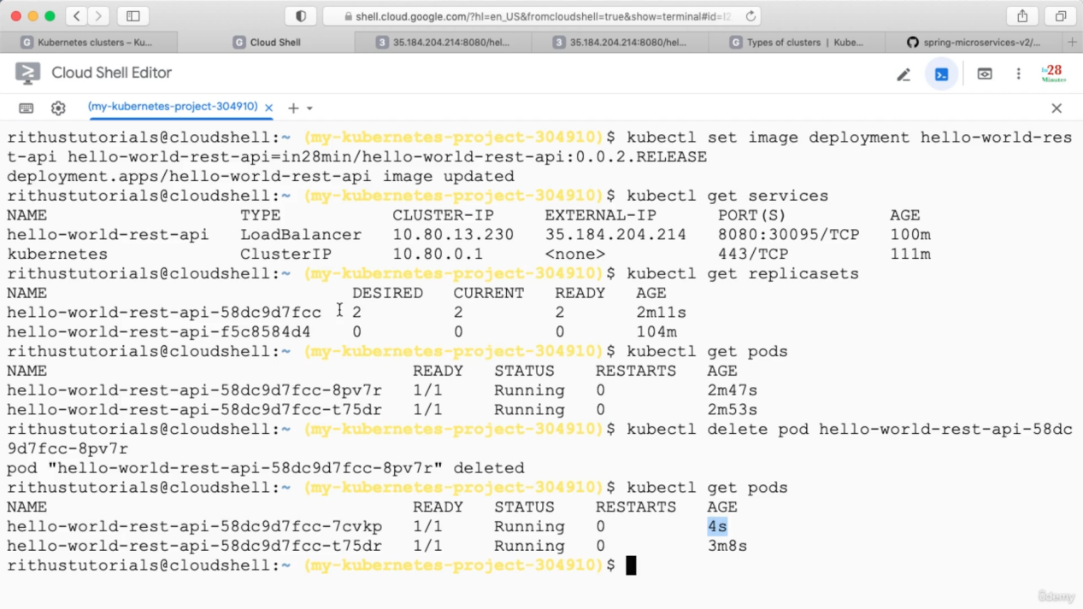

Deployment : shifting from one version to another without any downtime.

Replica set : ensure Specified number of POD are always running for a specific version.

Step 12 :

Step 18 : deleting all the resources

Kubectl delete service service-name (It will delete the service along with the load balancer associated with that service)

After service we will have to delete the deployment and then we need to delete the cluster.

Kubectl delete deployment deployment-name

Gcloud container clusters delete my-cluster --zone zone-name